**Introduction**

The All-In-One Travel App is a comprehensive platform designed to simplify and enhance the travel experience in Sri Lanka. Whether a local or an international tourist, this app empowers you to effortlessly book every aspect of your journey—from travel arrangements and accommodations to tickets for must-see attractions—all in one place. Tailored specifically for the vibrant destinations of Sri Lanka, the app brings together essential travel services, providing a user-friendly, seamless interface to plan, manage, and enjoy your trip.

With features that allow you to book transportation, find top-rated hotels, and reserve tickets for popular tourist spots, the All-In-One Travel App is the ultimate companion for a hassle-free exploration of Sri Lanka. Each service is designed with convenience in mind, enabling you to make reservations, view details, and manage your bookings directly from your mobile device. Explore Sri Lanka like never before with a travel app that keeps everything organized and at your fingertips.

In addition to booking, the All-In-One Travel App ensures that users have a smooth and personalized experience by providing details and tips about each destination. From local insights and hidden gems to essential travel tips, the app supports travelers in making informed choices, maximizing both enjoyment and comfort. For those seeking a truly immersive travel experience, this app is a gateway to discovering the beauty and culture of Sri Lanka in a way that’s tailored to your needs, making every trip memorable and stress-free.

**01 Get Started Screen**

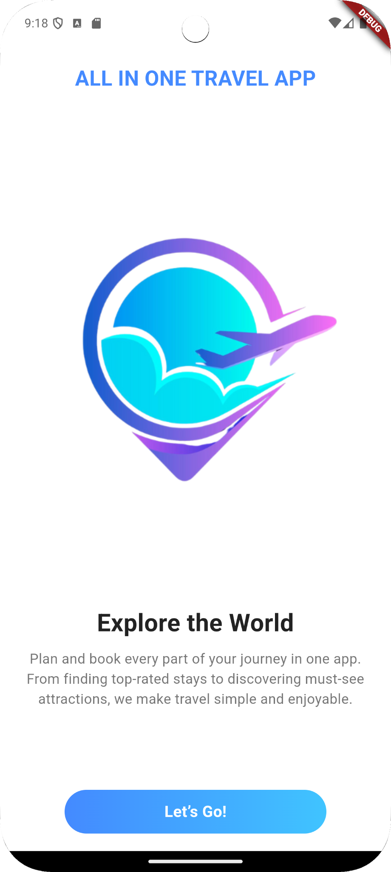

The launch screen of the All-In-One Travel App provides users with a welcoming introduction to the app's core functionality. With a visually appealing design and an inviting "Let’s Go!" button, the screen encourages users to explore and book various travel services seamlessly within Sri Lanka. This screen sets the stage for an intuitive user experience, allowing travelers to dive into everything the app has to offer.

**Features:**

* Explore the World: Highlights the app’s purpose of providing a comprehensive travel planning experience.
* Visual Appeal: The screen includes a vibrant logo and clean design to engage users right from the start.
* User-Friendly Onboarding: Guides users to start their journey within the app with an easy-to-spot "Let’s Go!" button.

**02 Booking Travels Intro Screen**

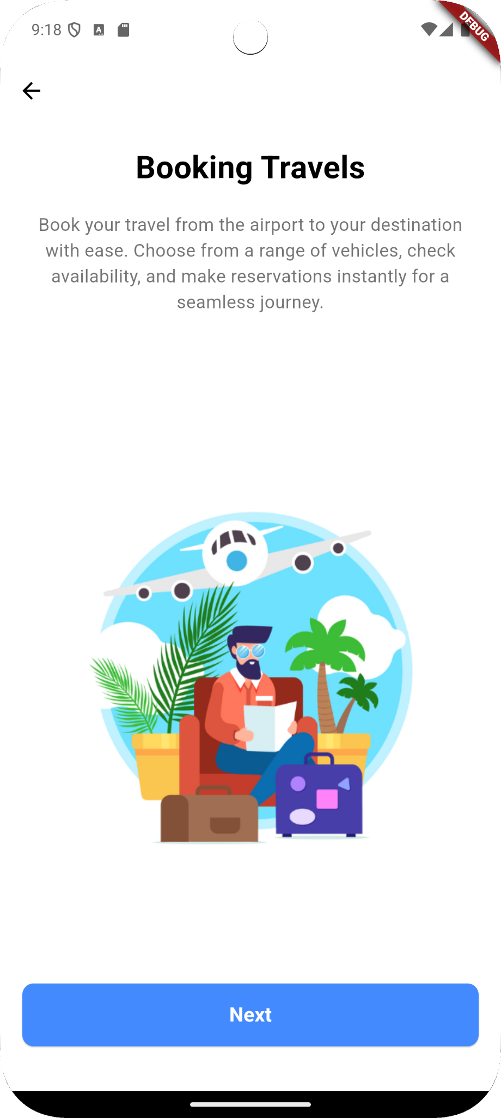

The "Booking Travels" screen introduces users to the travel booking feature of the All-In-One Travel App, designed to make planning journeys across Sri Lanka effortless. From arranging transport to and from the airport to selecting the ideal vehicle for a scenic journey through the island, this feature caters to the diverse travel needs of both locals and tourists. With options for various vehicle types, users can quickly check availability, book their transport, and receive instant confirmation—all in just a few taps.

**Features:**

* **Comprehensive Travel Choices**: Book transport options for all types of travel, from airport pickups to long-distance journeys.
* **Real-Time Availability**: Instantly view available options and secure your booking with ease.
* **Vehicle Selection**: Choose from a range of vehicles, ideal for city travel, scenic tours, or family excursions across Sri Lanka.
* **Instant Booking Confirmation**: Receive immediate confirmation for a seamless start to your travels.

**03 Booking Hotels Intro Screen**

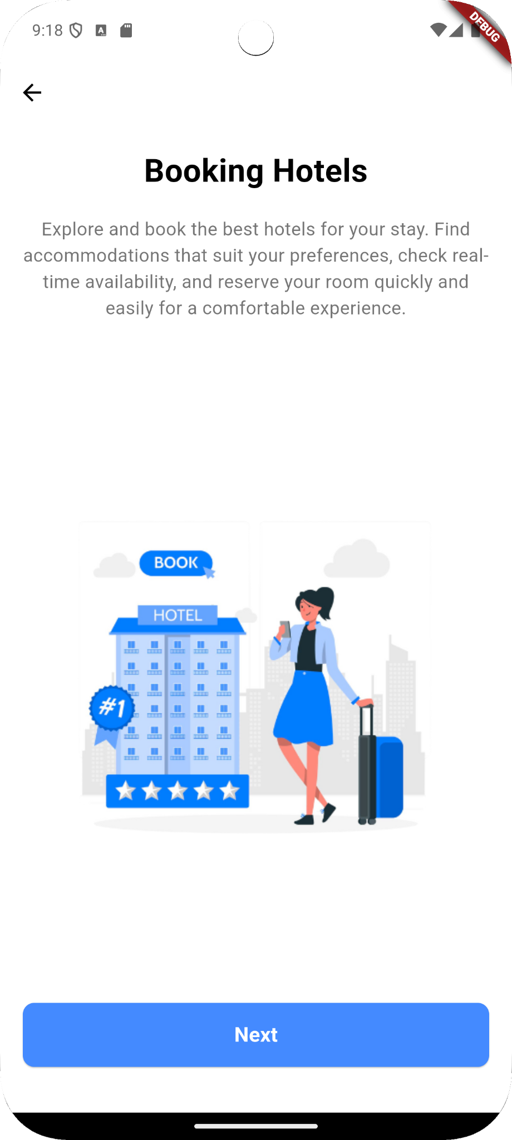

The "Booking Hotels" screen in the All-In-One Travel App enables users to seamlessly explore and book accommodations tailored to their preferences across Sri Lanka. With this feature, users can browse top-rated hotels, check real-time availability, and make reservations directly through the app. Whether you're looking for a quick overnight stay or a luxury resort experience, this platform ensures you find a place that fits your needs.

**Features:**

* **Extensive Hotel Options**: Access a wide range of hotels to suit different budgets and preferences.
* **Real-Time Room Availability**: Check room availability instantly and make bookings without delay.
* **Personalized Search Filters**: Easily find hotels that match your specific requirements, such as location, price, and amenities.
* **Instant Booking Confirmation**: Secure your booking in just a few taps and get immediate confirmation for peace of mind.

**04 Booking Tickets Intro Screen**

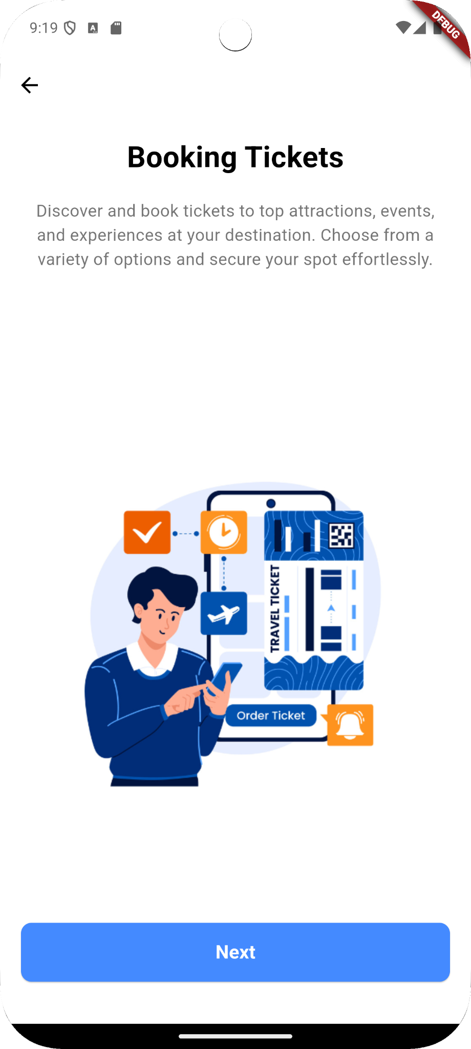

The "Booking Tickets" screen introduces the app’s functionality for purchasing tickets to popular attractions, events, shows, and other experiences in Sri Lanka. Designed to streamline the travel planning process, this feature allows users to explore and book tickets to some of the country's most sought-after tourist spots and cultural performances, ensuring a rich and immersive travel experience. From historic landmarks to entertainment events, this booking service covers a wide range of options to suit diverse interests.

In a country renowned for its vibrant culture and scenic beauty, accessing tourist attractions and events is essential for both local and international travelers. The ticket booking feature offers a convenient way to reserve spots, saving users the hassle of long queues or last-minute disappointments. With this app, travelers can make the most of their time in Sri Lanka by securing tickets in advance.

Features:

* **Access to Top Attractions**: Book tickets for famous historical sites, national parks, and scenic locations across Sri Lanka.
* **Event Reservations**: Discover and reserve tickets for cultural shows, festivals, and live performances.
* **Real-Time Availability**: Check and secure available spots instantly, helping you plan your itinerary efficiently.
* **Hassle-Free Booking**: Purchase tickets through the app with ease, ensuring you don't miss out on must-see experiences.

**05 Booking Management Intro Screen**

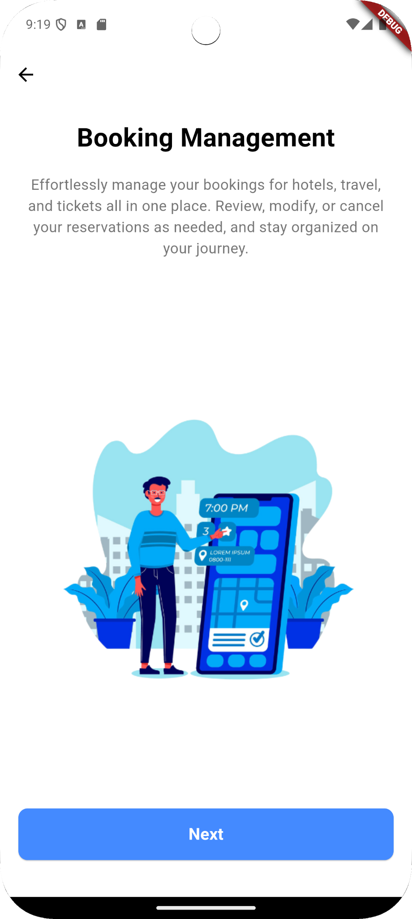

The "Booking Management" screen guides users on how to manage their travel, hotel, and ticket reservations all within the app. This feature centralizes all bookings, making it easy to review, modify, or cancel reservations as needed. It helps travelers stay organized and ensures they have control over their plans, from initial booking to any necessary adjustments, all in one place.

This tool is especially useful for travelers who may need to adapt their schedules due to unexpected changes, allowing them to handle all booking modifications seamlessly. By providing this level of flexibility and convenience, the app helps users enjoy a stress-free travel experience.

**Features:**

* Centralized Booking Management: View all your bookings in one place for easy access and organization.
* Modify Reservations: Change details like dates and times to suit evolving travel plans.
* Real-Time Updates: Stay informed on all booking statuses, ensuring accurate and up-to-date information on your journey.

**06 Authentication Screen**

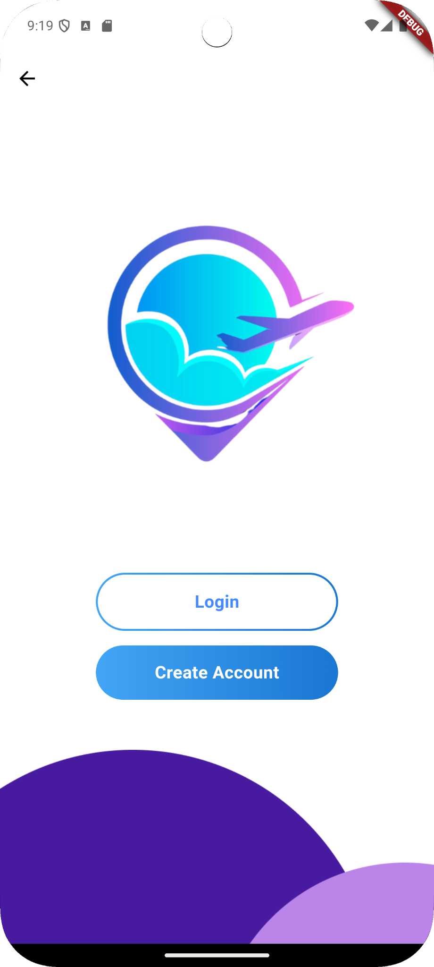

The Authentication Screen in the All-In-One Travel App serves as the entry point for users to access the platform. With a clean and minimalist design, this screen offers two primary options: Login and Create Account. Existing users can quickly log in to access their personalized dashboard and bookings, while new users can register to create an account, gaining access to all the app’s features.

This streamlined screen emphasizes ease of use, enabling users to securely enter their credentials or register without unnecessary steps. By making this process straightforward, the app ensures users can start exploring its features and functionalities right away.

Features:

* Login: Allows registered users to enter their credentials to securely access the app.
* Create Account: Enables new users to register a profile, granting them access to booking and management features.
* Simple Navigation: Offers a clear and easy-to-use layout, enhancing user experience and minimizing entry barriers.

**07 Create A New Account Screen**

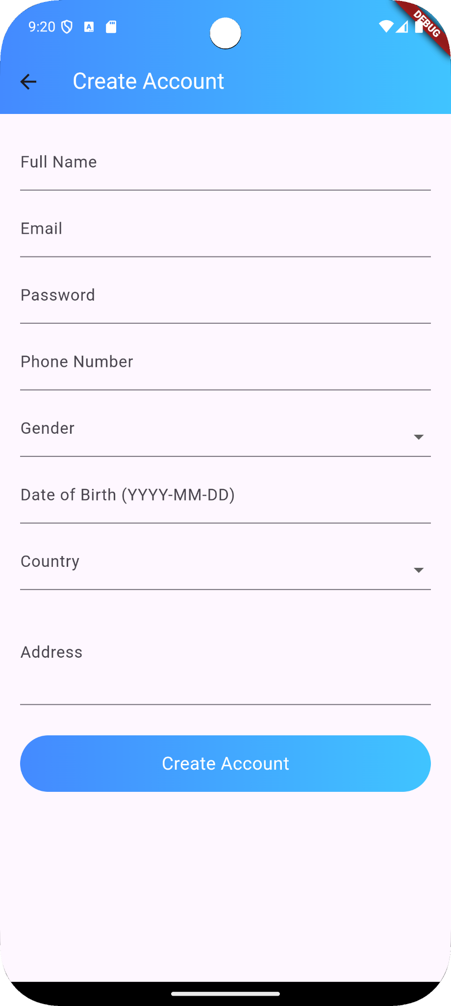

The Create Account screen in the All-In-One Travel App enables new users to register by providing essential personal details to set up their profile. This screen captures a comprehensive set of information, including full name, email, password, and phone number, ensuring secure account creation and easy future access.

Additionally, it asks for specific details like gender, date of birth, and country to personalize the user experience. The country selection helps tailor recommendations and content to the user's location, while other details ensure a smooth and efficient setup. This streamlined approach allows users to join the platform quickly and securely.

**Features:**

* Full Name: Captures the user’s name for personalized interactions.
* Email and Password: Ensures secure account setup with email verification.
* Phone Number: Provides an alternative contact method and security feature.
* Country: Adapts app content and features to the user’s geographic location.
* Address: Collects basic location details to simplify travel bookings and enhance the app's personalized offerings.

**08 Login Screen**

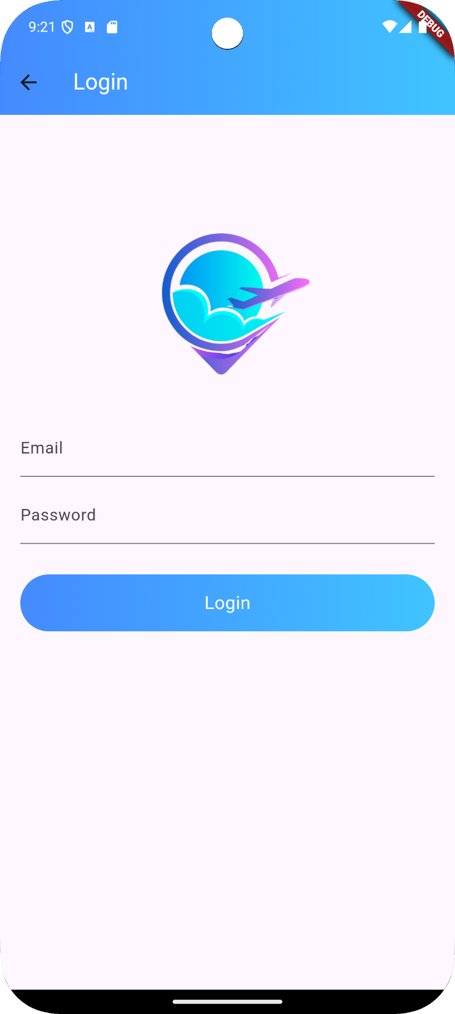

The Login Screen in the All-In-One Travel App provides a secure and streamlined entry point for users to access their accounts. Featuring a simple, user-friendly layout, this screen enables users to enter their registered email and password to log in. The interface is designed to facilitate quick access while ensuring that user data remains protected.

**Features:**

* Login Authentication: Allows users to securely enter their credentials to access their personalized travel dashboard.
* Invalid Login Alerts: If incorrect login details are entered, the system promptly alerts the user, helping them troubleshoot and providing clear guidance on possible issues.
* Session Management: Ensures that once users are logged in, their session remains secure and private, maintaining authentication throughout their interaction with the app.
* Easy Navigation: With a straightforward layout, users can quickly access their account, promoting a smooth, enjoyable app experience.

**09 Book Travels Screen**

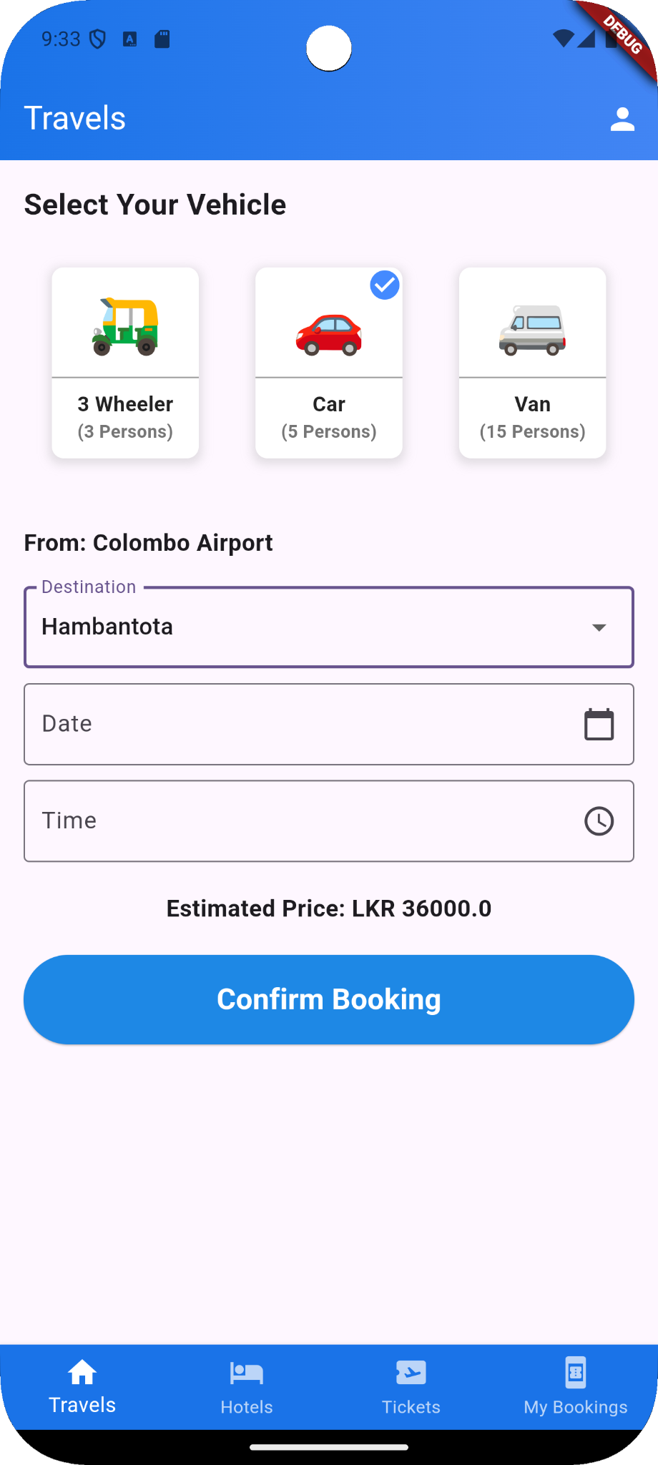

The **Book Travels** screen in the All-In-One Travel App provides a user-friendly interface that allows users to book transportation from a variety of vehicle options based on their travel needs. Users can select from vehicles like three-wheelers, cars, or vans, each displaying the maximum passenger capacity, making it easy for travelers to pick the most suitable option.

**Features**:

* **Vehicle Selection**: Users can choose the vehicle type that best suits their group size, ensuring they have ample space and comfort during their journey.
* **Destination and Pickup Input**: With fields to enter the destination, starting point (like Colombo Airport), date, and time, users can schedule their travel with precision.
* **Automatic Price Calculation**: The app calculates the estimated travel cost based on the selected destination and vehicle type, retrieving prices dynamically from the database. This feature provides transparency in pricing, so users know the fare upfront.
* **Confirm Booking**: With a prominent "Confirm Booking" button, users can easily finalize their travel arrangements in a single tap.

**10 Booking Success Screen**

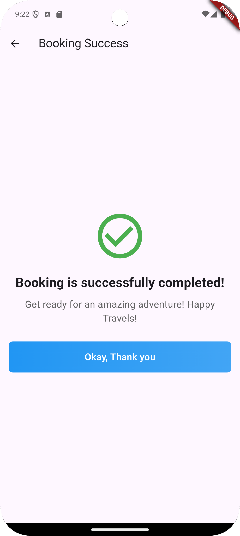

The **Booking Confirmation** screen serves as a final notification to users, letting them know that their booking was successfully completed. With a simple and visually appealing design, this screen uses a green checkmark to immediately signal success, providing users with a sense of assurance and completion. The message "Booking is successfully completed!" is followed by a friendly note encouraging users to prepare for their adventure, reinforcing a positive experience and excitement for the upcoming journey.

**Features**:

* **Success Notification**: Clearly indicates the booking’s successful completion with a prominent icon and confirmation message.
* **Encouraging Message**: Adds a personal touch, wishing users a great adventure and inviting them to look forward to their trip.
* **Final Acknowledgment Button**: A clear "Okay, Thank you" button allows users to acknowledge the message and return to their main activities in the app, maintaining a smooth and user-friendly flow.

**11 Book Hotels Screen**

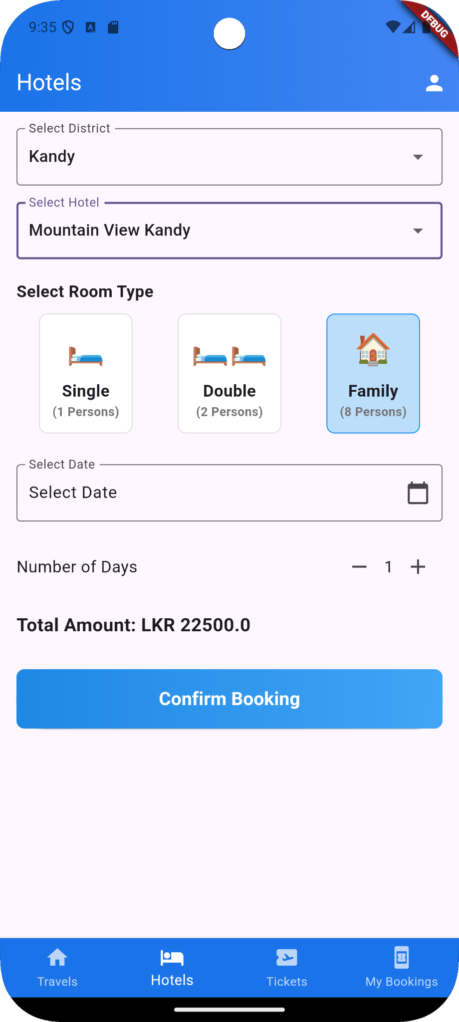

The Hotel Booking screen provides users with an efficient way to find and book hotel accommodations in Sri Lanka. This screen is designed to streamline the booking process by allowing users to search for hotels by district, making it easy to find accommodation in their desired location. Users can select specific hotels, view room types (Single, Double, or Family), and see corresponding room capacities and prices.

Features:

* District-Based Hotel Search: Enables users to filter hotels by district, allowing for a more targeted search experience.
* Room Type Selection: Offers multiple room options (Single, Double, Family) to suit various group sizes and preferences.
* Date and Duration Selection: Users can specify check-in dates and the number of nights they plan to stay, ensuring accurate booking details.
* Automatic Price Calculation: The app dynamically calculates the total cost based on the selected room type, duration, and hotel pricing data from the database.
* Clear Price Display: The total amount is displayed prominently to keep users informed before confirming their booking.

**12 Book Tickets Screen**

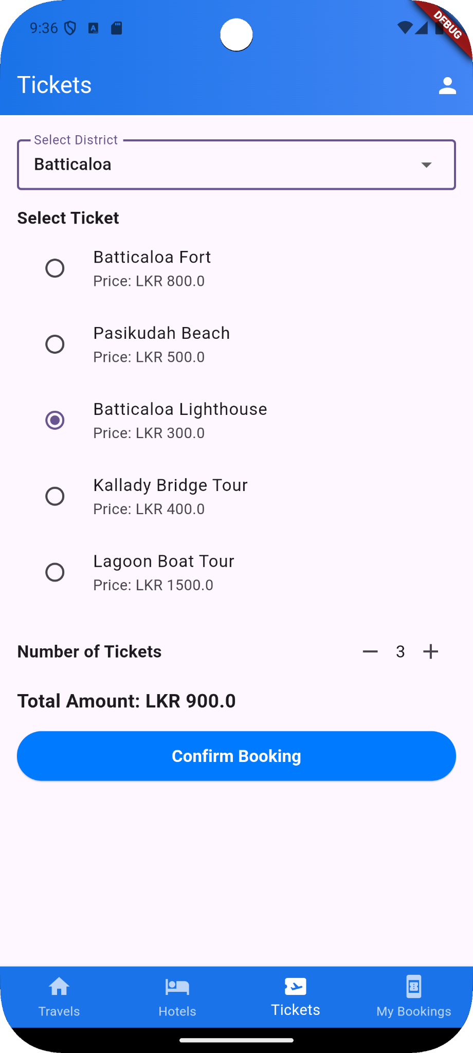

The Tickets Booking screen is an invaluable tool for travelers exploring Sri Lanka. This feature simplifies the process of booking tickets for popular tourist attractions, events, shows, and other activities by providing a district-based listing. By selecting a district, users can quickly view available attractions and events, allowing them to plan their itinerary based on the types of **experiences each region offers.**

**Features:**

* District-Based Listings: Helps users discover and select activities and attractions by district, giving travelers a comprehensive view of entertainment options within specific areas.
* Activity and Attraction Details: Each listing shows the ticket price and relevant details, enabling users to make informed decisions.
* Quantity Selection and Automatic Price Calculation: Users can specify the number of tickets required, with the app dynamically calculating the total cost for easy budgeting.
* Quick Booking Confirmation: Once the selections are made, the app provides a seamless booking confirmation process to secure tickets instantly.

**13 My Booking Screen**

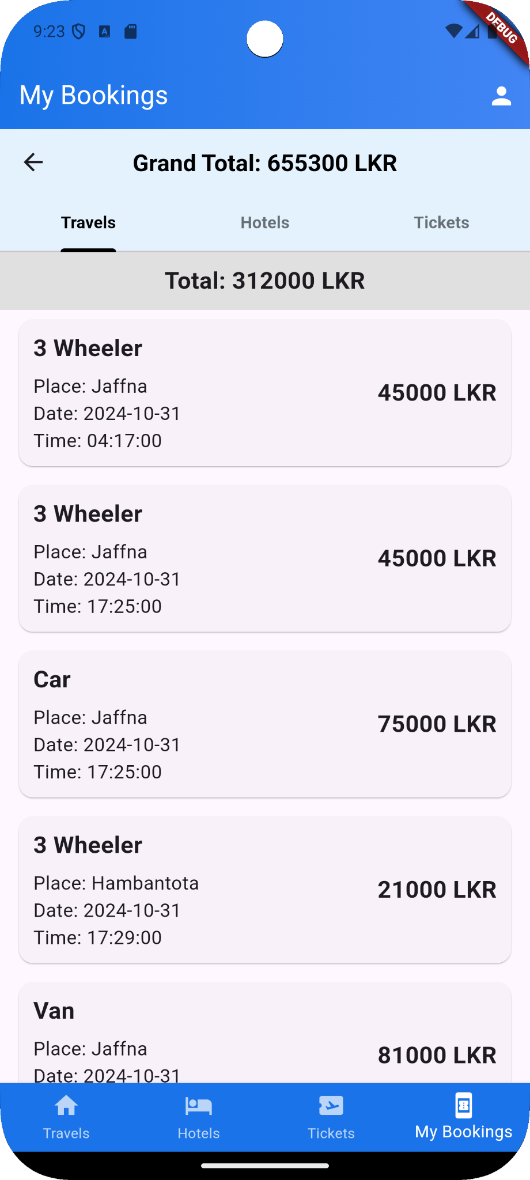

The My Bookings screen provides a comprehensive view of all reservations made by the user across different services—travels, hotels, and tickets. This screen is designed for easy navigation and quick access, enabling users to review all their bookings in a well-organized format.

**Features:**

* Tabbed Navigation: The screen includes subtabs for each service type—Travels, Hotels, and Tickets. Users can easily switch between these tabs to see specific bookings, providing a streamlined viewing experience.
* Individual Totals and Grand Total: At the top of the screen, the app displays a Grand Total of all bookings across services, giving users a complete summary of their spending. Additionally, each tab displays a subtotal for the specific category, helping users track expenses in each area.
* Booking Details: Each booking card within the tab displays essential information, including the type of service (vehicle type for travels, hotel name, or ticket type), location, date, time, and cost, giving users a detailed overview of each reservation.

The My Bookings screen is a user-friendly and valuable feature that keeps all bookings organized, making it easy for travelers to manage their itineraries and budget at a glance. This layout ensures travelers stay well-informed and fully prepared for their journey.

**14 My Booking Screen (Hotels Tab)**

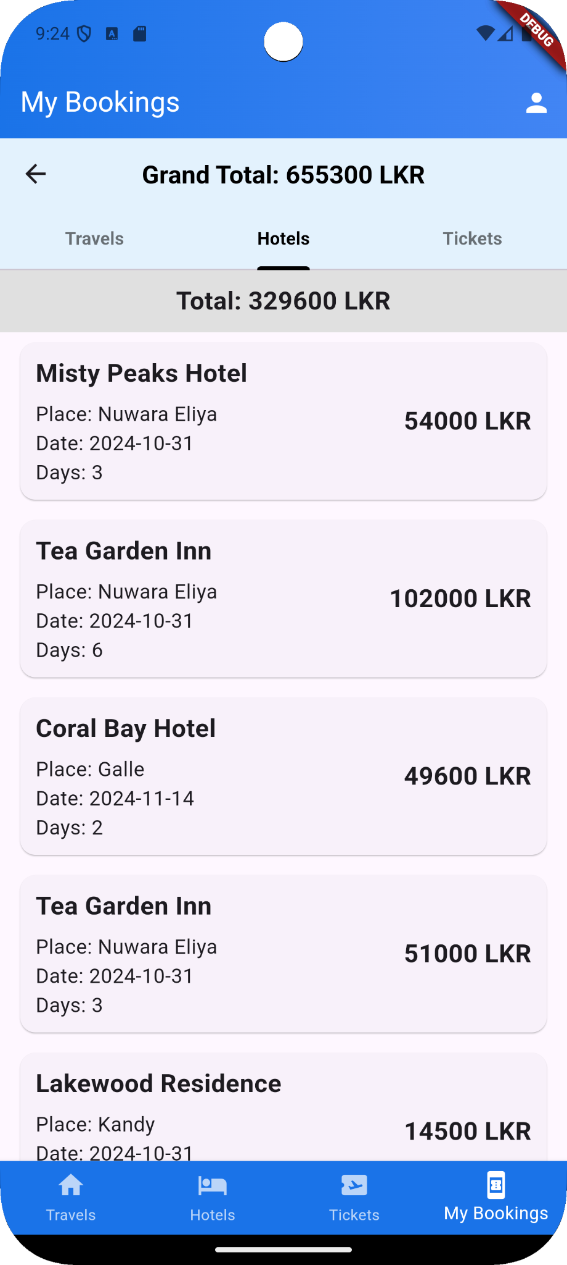

The My Bookings - Hotels Tab provides users with a detailed summary of all their hotel reservations, presented in a clear and organized format. This screen allows users to review each booking, including essential details like the hotel name, location, date, and the duration of the stay (in days).

**Features:**

* Comprehensive Booking Information: Each booking card displays vital information about the reservation, including the hotel name, place, check-in date, and number of days for the stay. This feature helps users recall important details at a glance.
* Cost Display: For each reservation, the corresponding price is prominently displayed, providing users with a quick view of their expenditure per booking.
* Tab Subtotals and Grand Total: At the top of the tab, a Total amount is calculated for the hotel bookings, giving users a quick overview of their hotel-related expenses. Above this, the Grand Total aggregates the costs from all services (travels, hotels, tickets), offering a complete financial summary for their bookings.

The My Bookings - Hotels Tab is a practical feature, designed to give travelers full visibility into their accommodation arrangements and costs, helping them to manage their itinerary and budget with ease.

**15 My Booking Screen (Tickets Tab)**

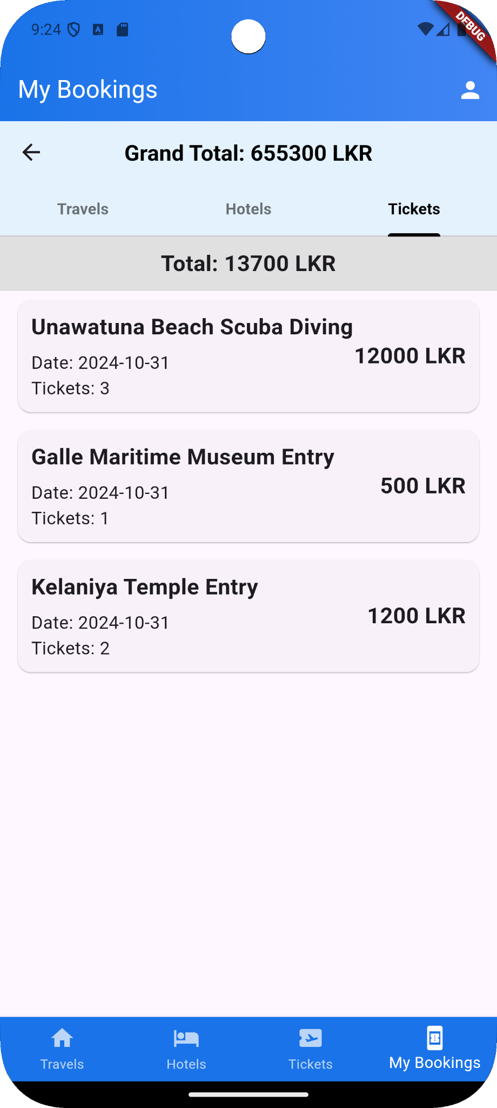

The My Bookings - Tickets Tab provides users with a comprehensive view of all their reserved tickets for various attractions and experiences. This screen allows users to track details for each ticketed activity, including the venue, date, and the number of tickets purchased.

**Features:**

* Detailed Booking Information: Each card displays specific information about the ticketed attraction, such as the location (e.g., Unawatuna Beach for Scuba Diving, Galle Maritime Museum, Kelaniya Temple), date, and number of tickets.
* Cost Display: Each booking card clearly shows the total cost for the tickets, allowing users to review their spending for individual activities at a glance.
* Tab Subtotal and Grand Total: The Total for all ticket bookings in this tab is displayed at the top, providing a quick overview of expenses related to ticketed activities. Additionally, the Grand Total aggregates all costs across travels, hotels, and tickets, helping users manage their budget effectively.

The My Bookings - Tickets Tab is a user-friendly feature that gives travelers a complete overview of their scheduled experiences and activities, ensuring they can plan their trip itinerary with ease and manage their spending across different ticketed events.

**16 My Profile Screen**

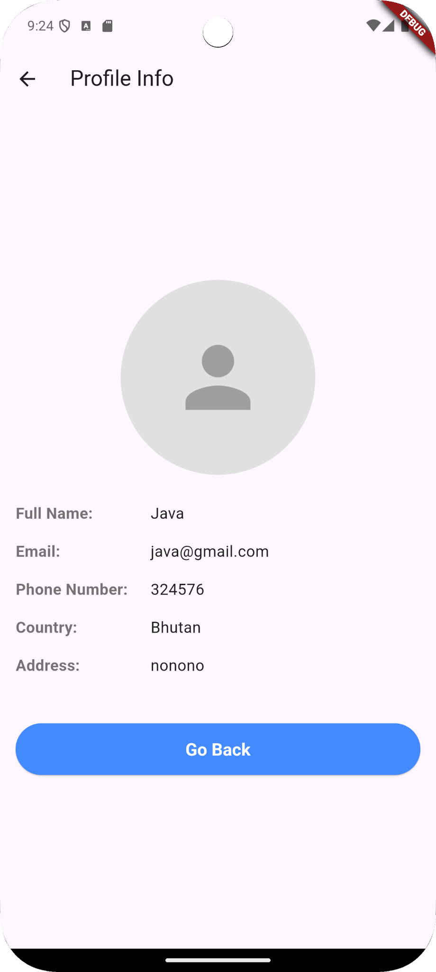

The My Profile Screen provides users with a clear and simple interface to view their personal details associated with the app. This screen displays key information about the user, including their full name, email address, phone number, country, and address, in a concise and organized manner. The profile screen enhances the user's sense of identity within the app, showing that their personal data is safely stored and easily accessible.

Features:

* User Information Display: The screen shows essential details about the user, such as their name, email, phone number, country, and address. This makes it easy for users to quickly reference their information when needed.
* Profile Picture Placeholder: The default profile icon provides a space for user identity, though the app does not currently allow image uploads or profile customization.
* Navigation Button: The "Go Back" button allows users to return to the previous screen with a single tap, ensuring smooth navigation within the app.

This screen currently only supports viewing information, with no option to edit profile details. The lack of editing capabilities suggests that any updates or changes to user information may require contacting support or accessing an external platform. This profile screen is an efficient and straightforward feature, ideal for users who need to quickly review their registered details.

**17 Password Change Screen**

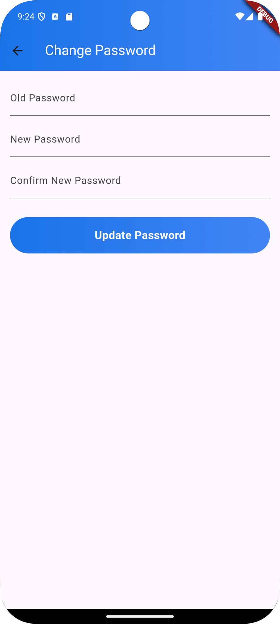

The Change Password Screen provides users with a secure and straightforward interface for updating their account password. This screen requires users to input their current password, followed by the new password they wish to set. Additionally, the new password must be confirmed in the final field to ensure accuracy and avoid any potential errors.

**Features:**

* Old Password Verification: Users are prompted to enter their current password to verify their identity before making changes, adding a layer of security to the process.
* New Password Input: Users can type their desired new password, allowing them to improve account security with a stronger or updated password.
* Confirmation of New Password: The system requires users to re-enter the new password to confirm it, reducing the chances of accidental errors.
* Update Password Button: A clearly labeled button, "Update Password," enables users to submit their changes with a single tap.

This screen is designed to make password changes simple and secure, giving users confidence in maintaining their account safety. By verifying the old password and confirming the new one, the screen ensures that only authorized users can make changes to their account credentials.